Security & PCI Compliance
# Source: AI Source: Provided by: [Data Path: Persons Table -> ID Column: 1, Name_En Column: Motasem Essam] -> From: [ChatGPT] on [1/21/2026]
When building a custom bank integration, Security & PCI Compliance is one of the most critical components. You're directly handling sensitive financial data — especially cardholder information — so you must meet strict global security standards and implement strong protective measures.

🛡️ What is PCI Compliance?
# Source: AI Source: Provided by: [Data Path: Persons Table -> ID Column: 1, Name_En Column: Motasem Essam] -> From: [ChatGPT] on [1/21/2026]
PCI DSS stands for Payment Card Industry Data Security Standard.
It's a set of rules created by major card networks (Visa, Mastercard, etc.) to protect cardholder data and prevent fraud or theft.
If you're handling, processing, or storing card data directly on your systems, you are responsible for meeting PCI DSS requirements.

✅ Goals of PCI Compliance
# Source: AI Source: Provided by: [Data Path: Persons Table -> ID Column: 1, Name_En Column: Motasem Essam] -> From: [ChatGPT] on [1/21/2026]
- Build and maintain a secure network
- Protect cardholder data
- Maintain a vulnerability management program
- Implement strong access control
- Monitor and test networks regularly
- Maintain an information security policy

🔧 Core Security Practices in Custom Integrations

1. Use HTTPS Everywhere
# Source: AI Source: Provided by: [Data Path: Persons Table -> ID Column: 1, Name_En Column: Motasem Essam] -> From: [ChatGPT] on [1/21/2026]
- All forms and APIs that touch payment data must use TLS encryption (HTTPS).

2. Never Store Raw Card Data
# Source: AI Source: Provided by: [Data Path: Persons Table -> ID Column: 1, Name_En Column: Motasem Essam] -> From: [ChatGPT] on [1/21/2026]
- Do not store:
  - Full card numbers (PAN)
  - CVV codes
  - Track data from magnetic stripes
- If you must store partial data (e.g., last 4 digits), it must be encrypted.

3. Tokenization
# Source: AI Source: Provided by: [Data Path: Persons Table -> ID Column: 1, Name_En Column: Motasem Essam] -> From: [ChatGPT] on [1/21/2026]
- If your bank supports it, use tokenization:
  - Replace card data with a secure, meaningless token
  - Reduces PCI scope (you don’t store real card numbers)

4. Encryption at Rest and In Transit
# Source: AI Source: Provided by: [Data Path: Persons Table -> ID Column: 1, Name_En Column: Motasem Essam] -> From: [ChatGPT] on [1/21/2026]
- All payment data should be encrypted during transmission (TLS) and when stored (if required).

5. Access Control & Authentication
# Source: AI Source: Provided by: [Data Path: Persons Table -> ID Column: 1, Name_En Column: Motasem Essam] -> From: [ChatGPT] on [1/21/2026]
- Restrict access to sensitive systems only to authorized staff.
- Use multi-factor authentication for admin access.

6. 3D Secure Support (e.g., OTP, biometric)
# Source: AI Source: Provided by: [Data Path: Persons Table -> ID Column: 1, Name_En Column: Motasem Essam] -> From: [ChatGPT] on [1/21/2026]
- Supports added verification during payment (common in MENA banks).
- Reduces chargebacks and liability for fraud.

7. Logging and Auditing
# Source: AI Source: Provided by: [Data Path: Persons Table -> ID Column: 1, Name_En Column: Motasem Essam] -> From: [ChatGPT] on [1/21/2026]
- Track all access to payment systems.
- Log transaction attempts, errors, and any unusual activity.

📋 PCI DSS Compliance Levels (Based on Volume)
# Source: AI Source: Provided by: [Data Path: Persons Table -> ID Column: 1, Name_En Column: Motasem Essam] -> From: [ChatGPT] on [1/21/2026]
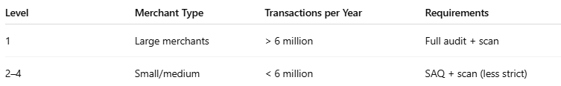
Level | Merchant Type | Transactions per Year | Requirements
1 | Large merchants | > 6 million | Full audit + scan
2–4 | Small/medium | < 6 million | SAQ + scan (less strict)
For most startups and mid-sized businesses, SAQ-D (Self-Assessment Questionnaire) is required if handling card data directly.

❗ What Happens If You Don’t Comply?
# Source: AI Source: Provided by: [Data Path: Persons Table -> ID Column: 1, Name_En Column: Motasem Essam] -> From: [ChatGPT] on [1/21/2026]
- Fines from card networks
- Loss of ability to accept card payments
- Legal liability in case of data breaches
- Reputation damage

🧩 How to Avoid Full PCI Scope
# Source: AI Source: Provided by: [Data Path: Persons Table -> ID Column: 1, Name_En Column: Motasem Essam] -> From: [ChatGPT] on [1/21/2026]
If you don’t want to deal with heavy PCI requirements:
- Use tokenization from your bank
- Redirect to the bank’s hosted payment page
- Use an iframe from the bank to capture card data securely
This offloads risk and reduces your compliance responsibility.

🧠 Summary
# Source: AI Source: Provided by: [Data Path: Persons Table -> ID Column: 1, Name_En Column: Motasem Essam] -> From: [ChatGPT] on [1/21/2026]
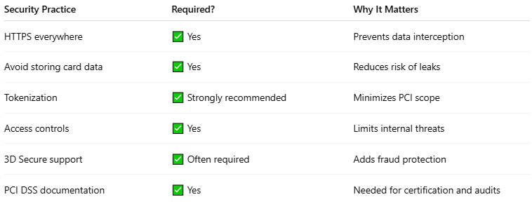

Security Practice | Required? | Why It Matters
HTTPS everywhere | ✅ Yes | Prevents data interception
Avoid storing card data | ✅ Yes | Reduces risk of leaks
Tokenization | ✅ Strongly recommended | Minimizes PCI scope
Access controls | ✅ Yes | Limits internal threats
3D Secure support | ✅ Often required | Adds fraud protection
PCI DSS documentation | ✅ Yes | Needed for certification and audits

